**DB On VM in AZURE**

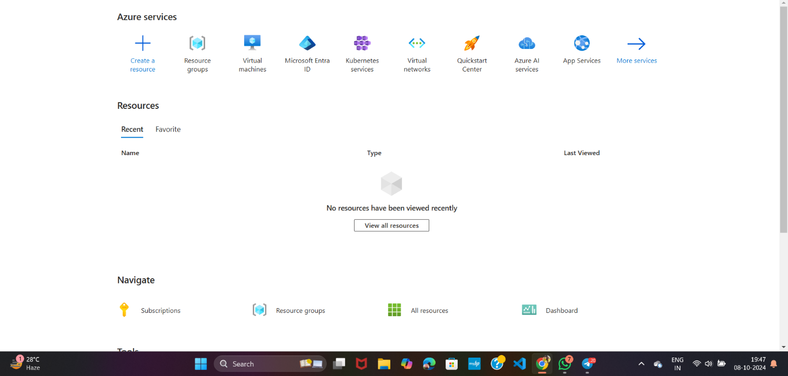**\*Select Resource group**

**\*Create Resource Group**

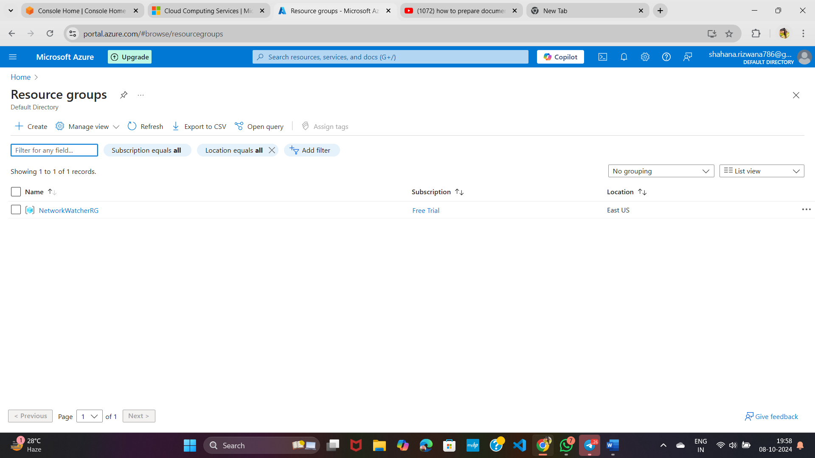

**\*Give Resource Group Name and Select Region**

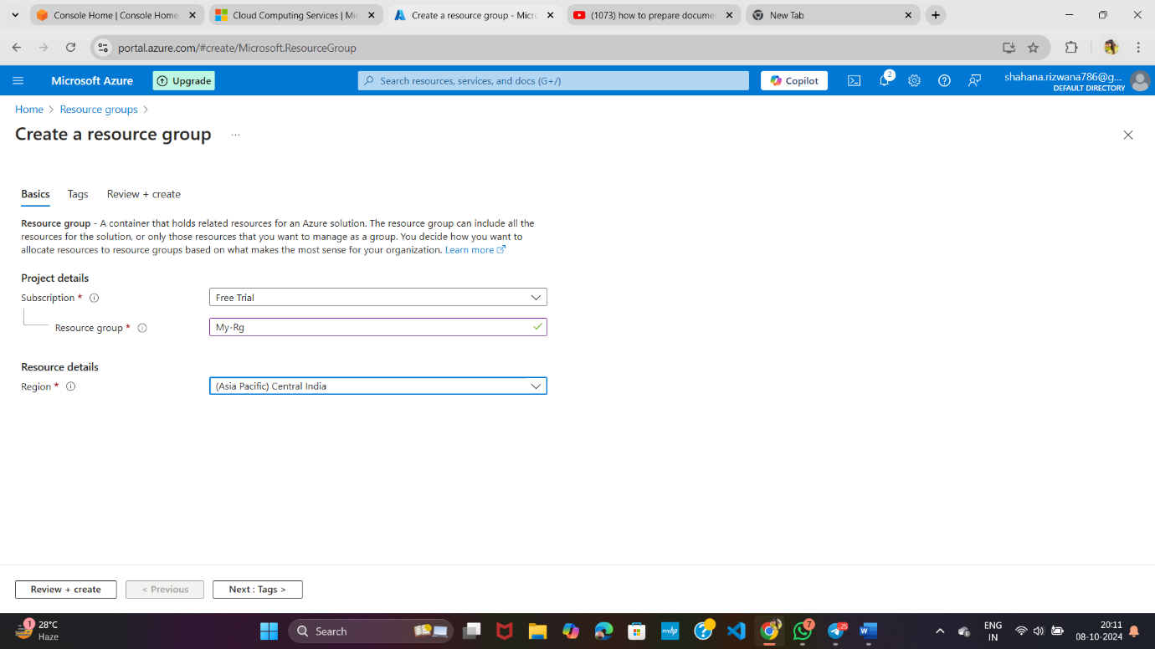**\*Then click on Review + Create**



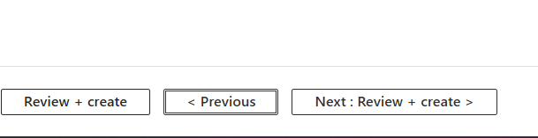

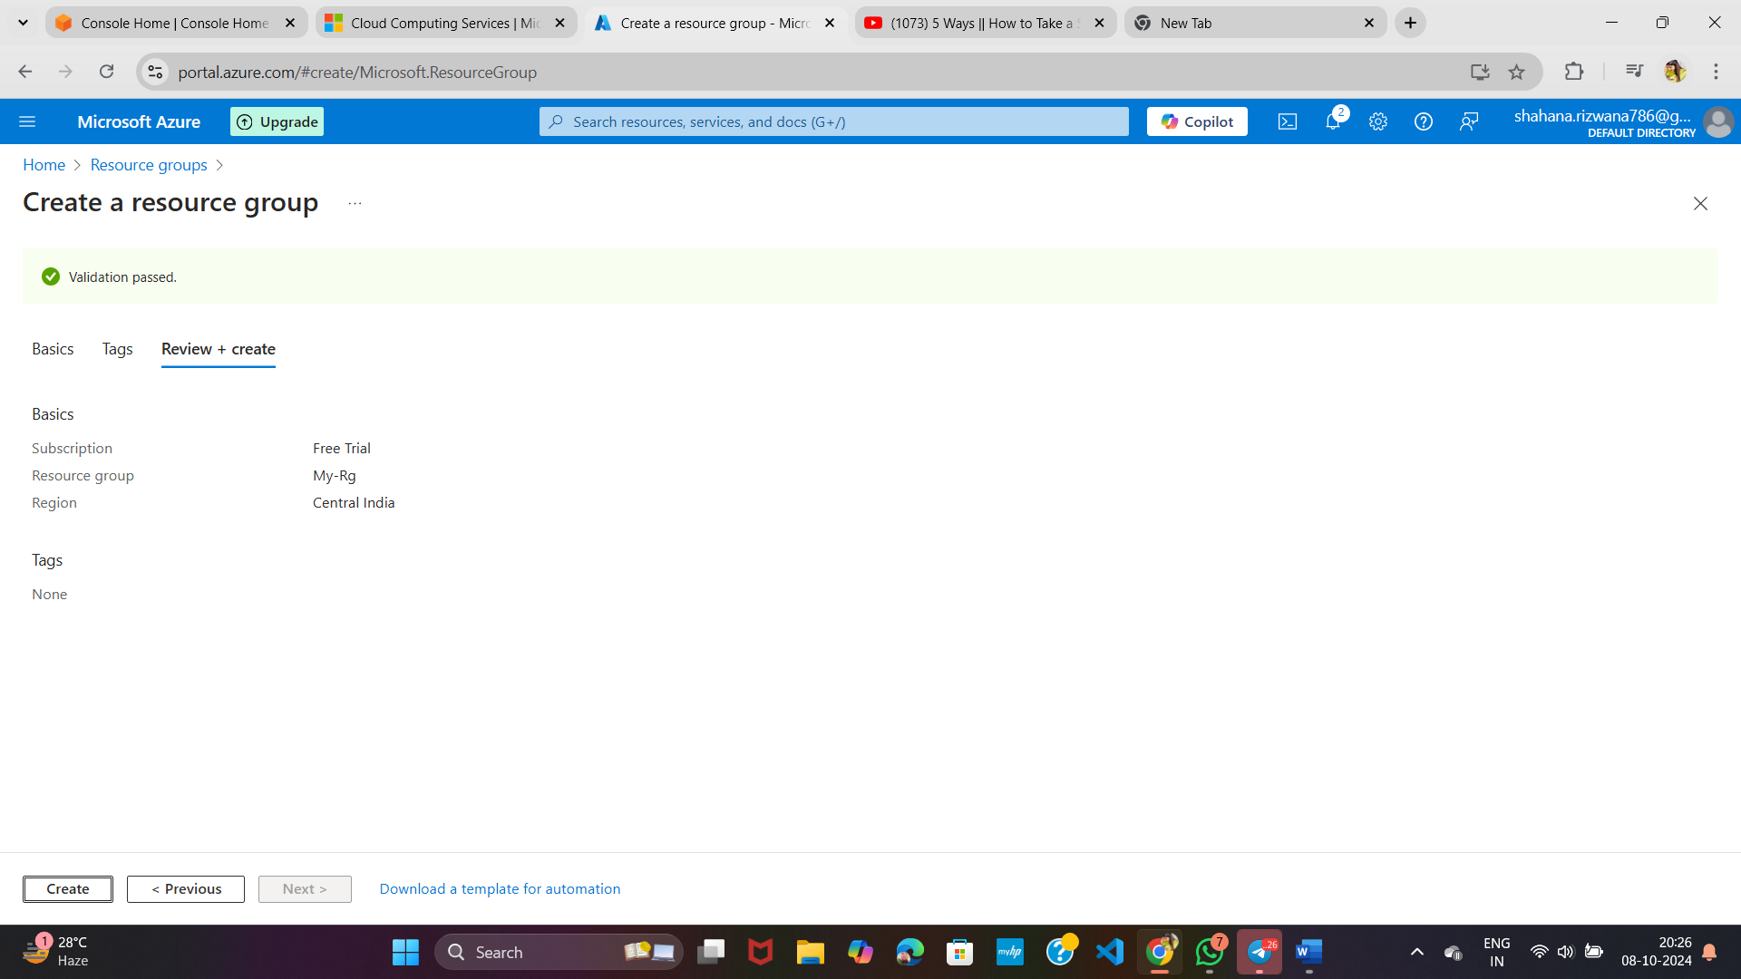

**\*Search VM**

**\*Select Virtual Machine**

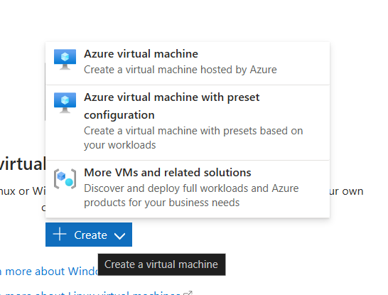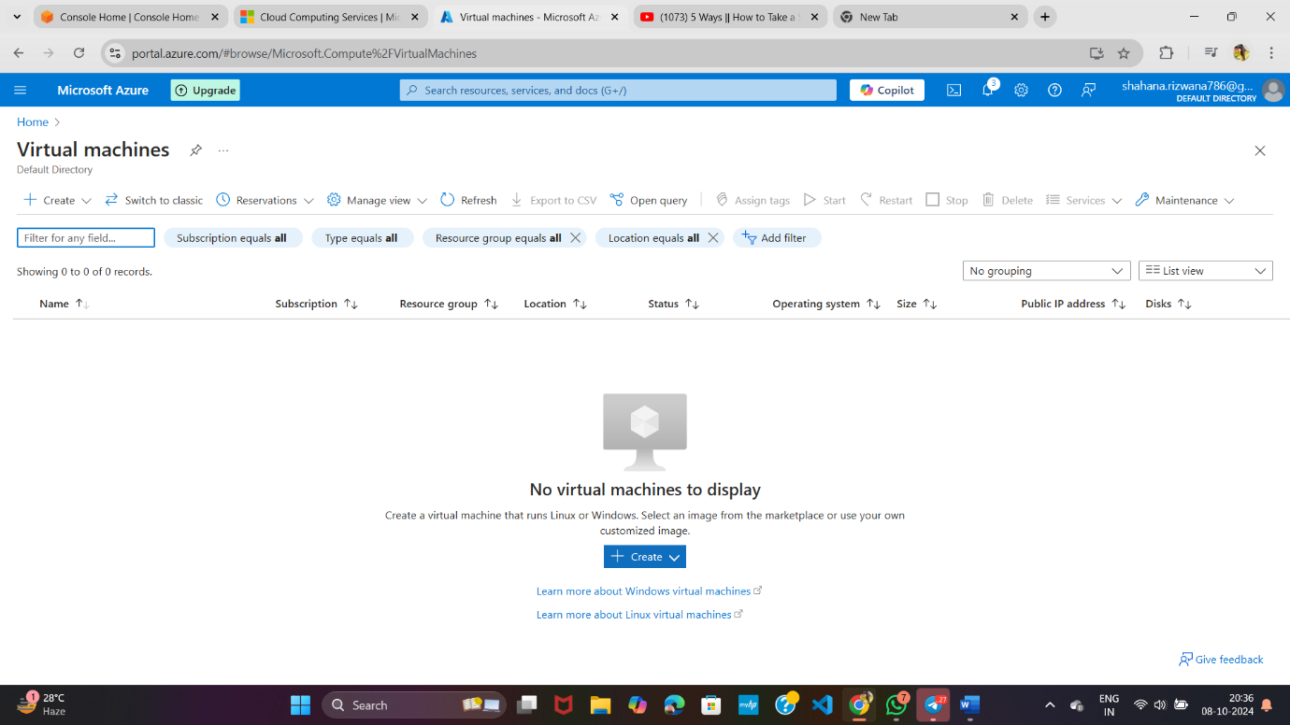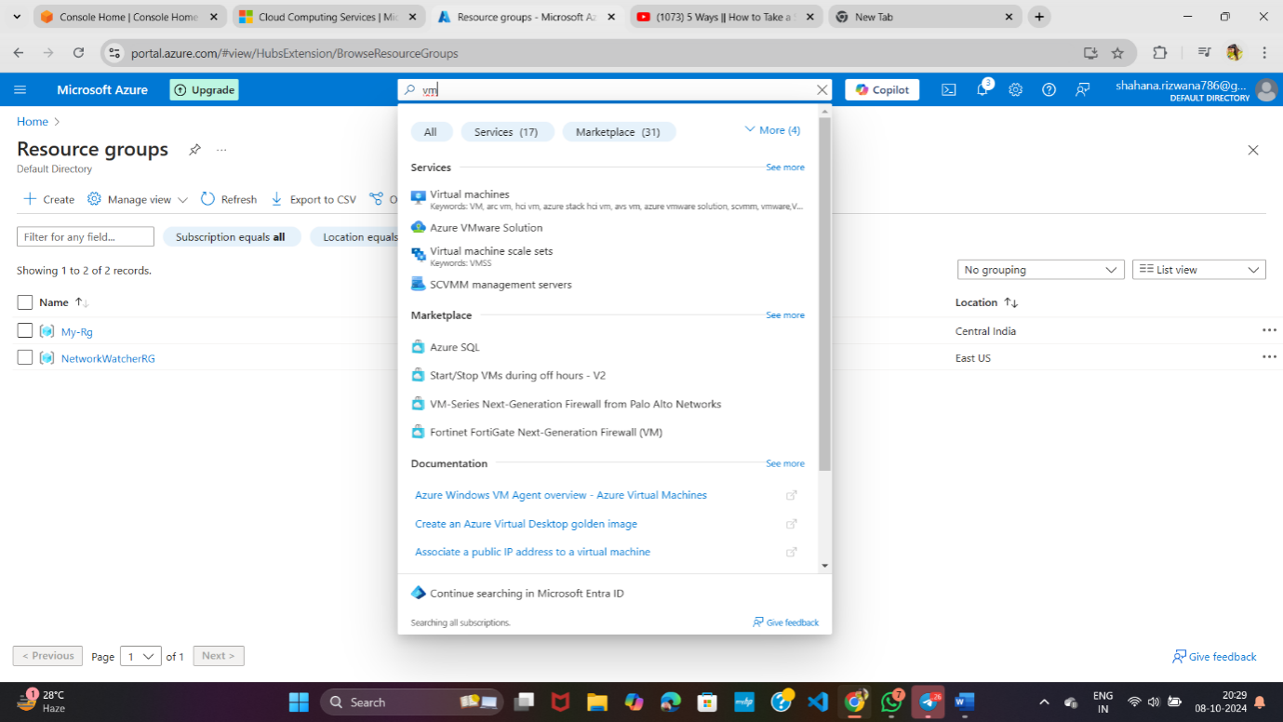



**\*Select RG and give VM name**

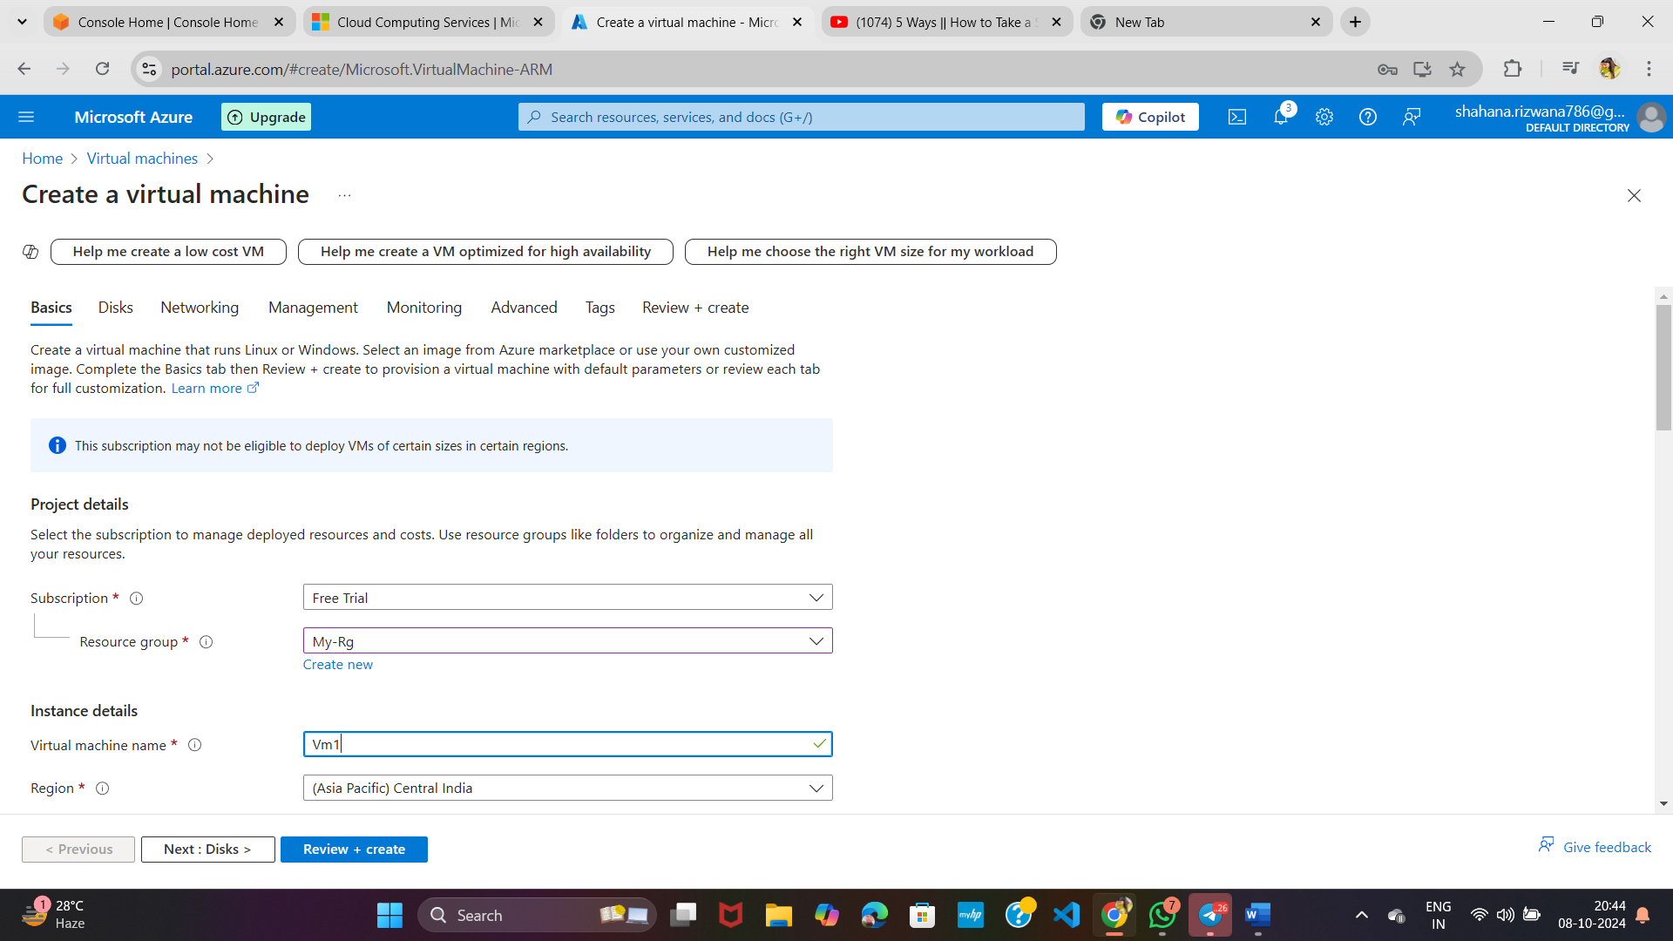

**\*Choose Authentication type then click on next**

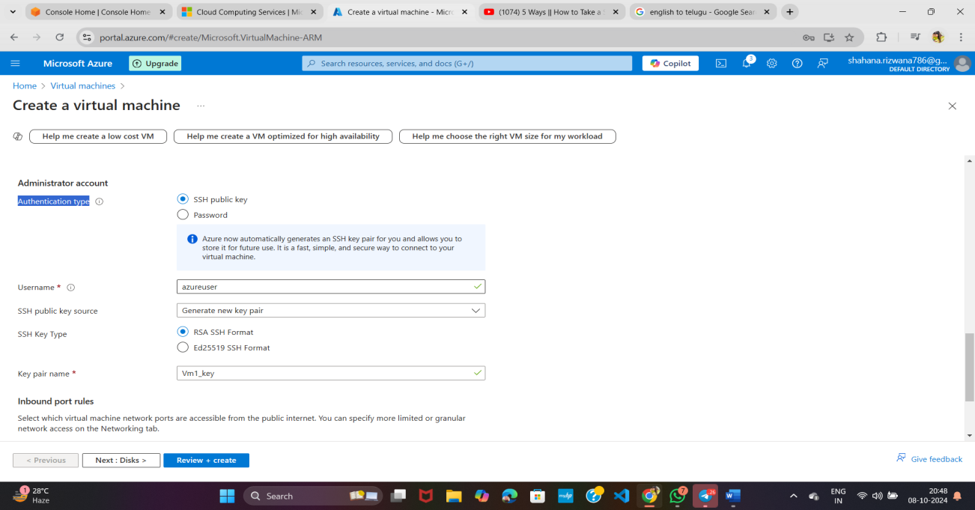

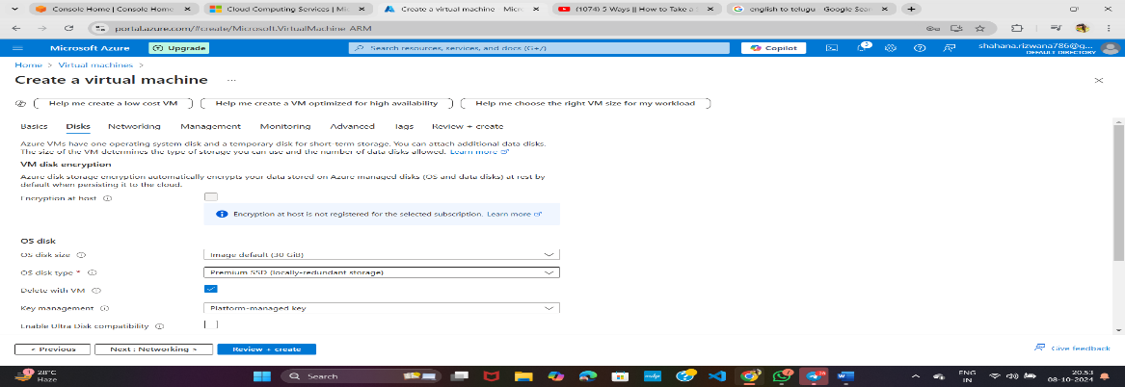**\*Disks keep as is then click on next**

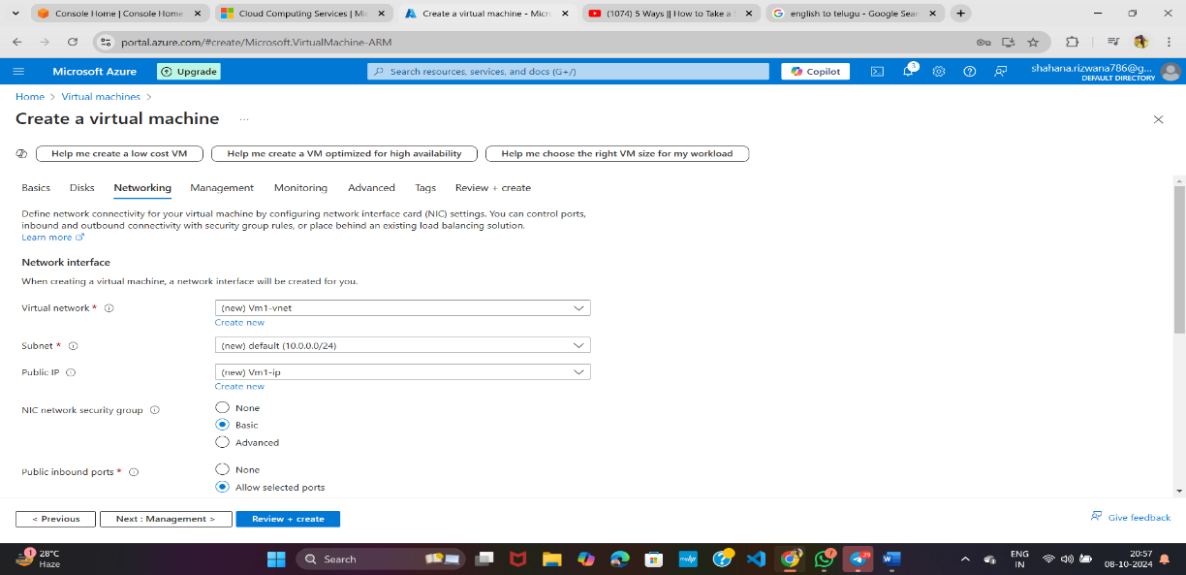

**\*If you want to create a private server, click here otherwise leave and click on Review and Create**

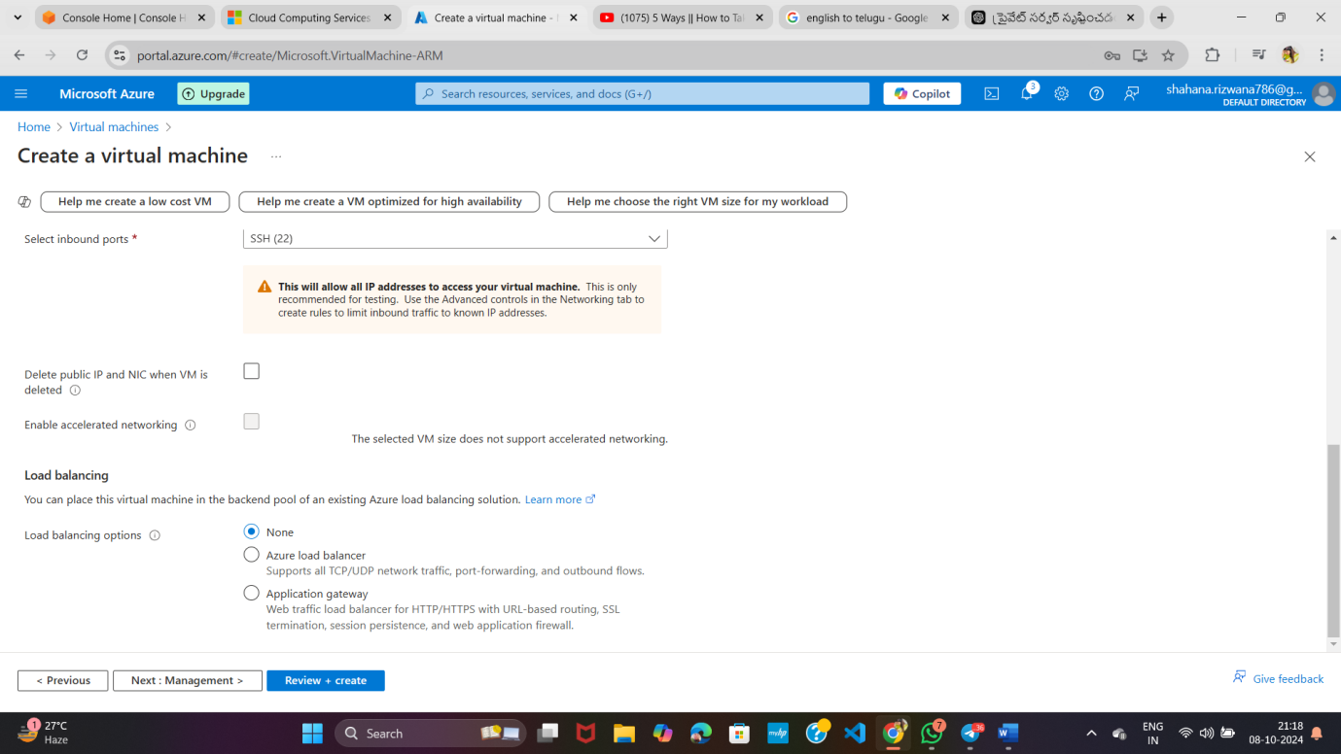

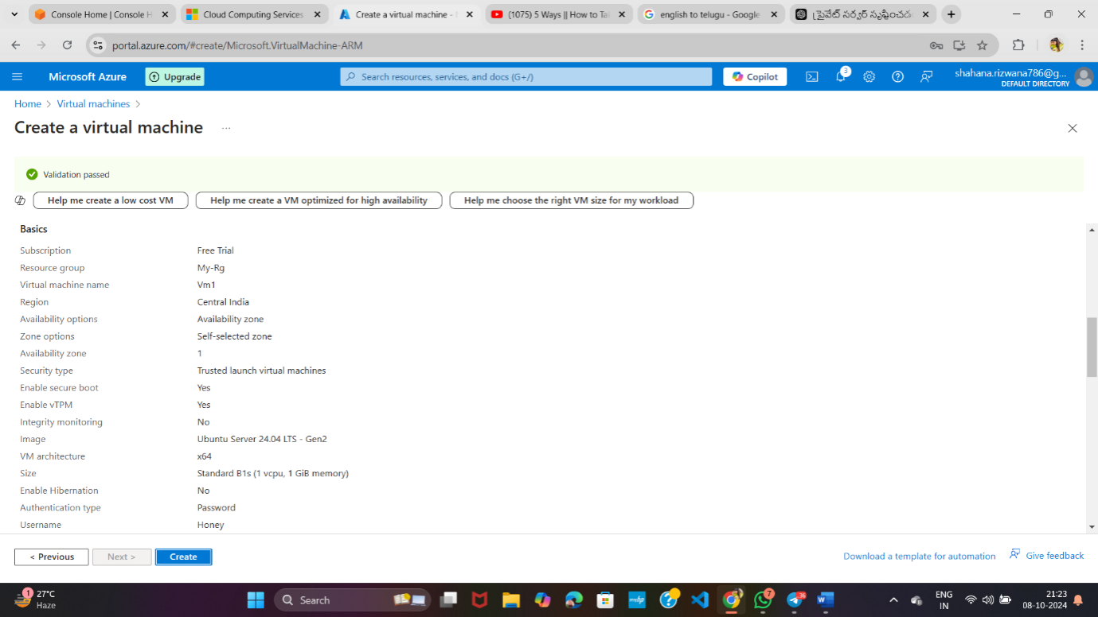

**\*It will take some time to create**

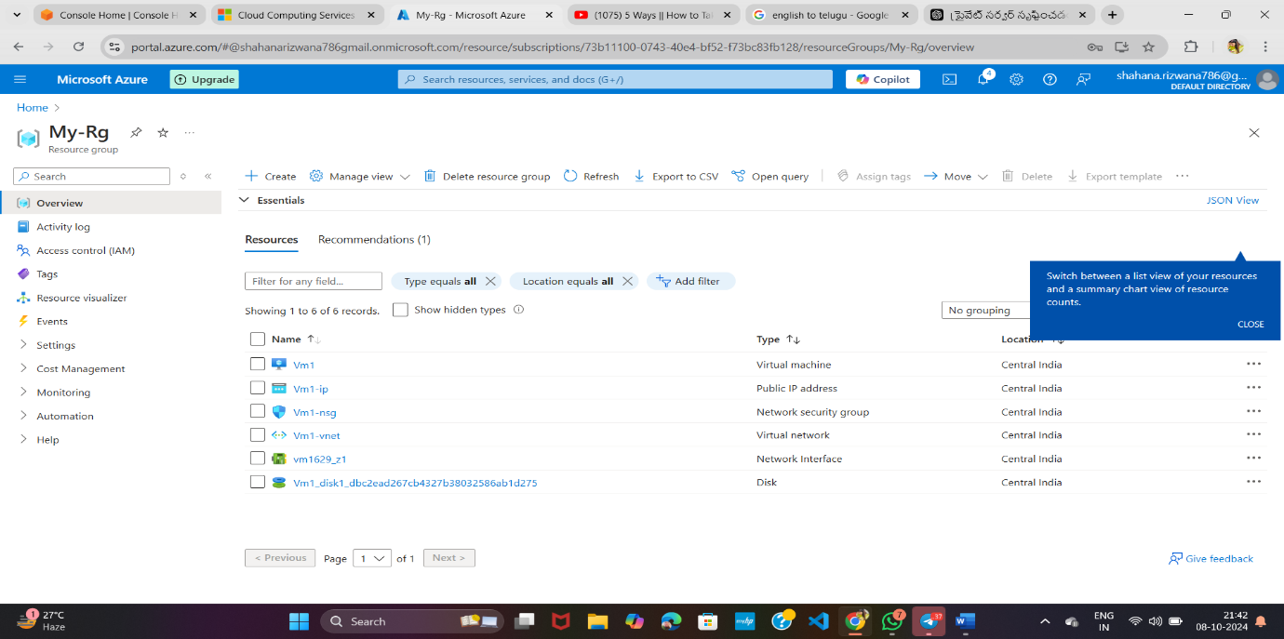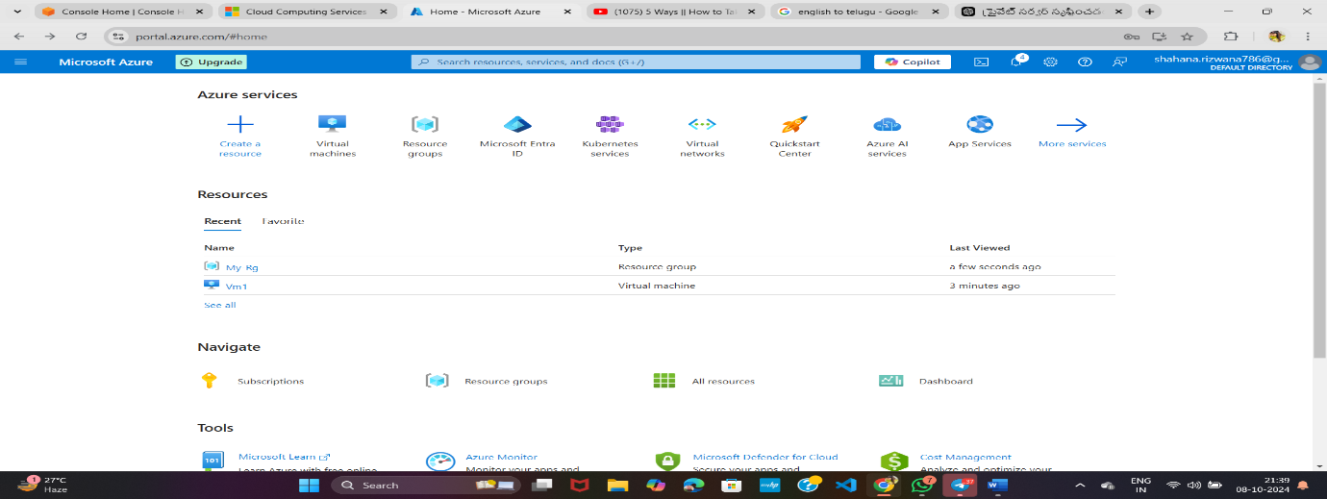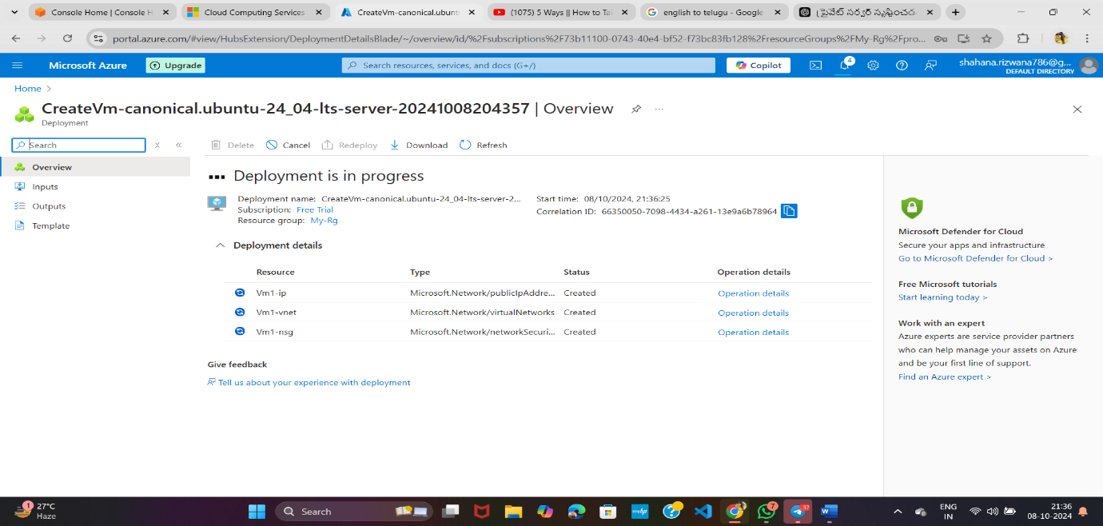**\*Then Click on your Resource group then click on Vm1 *And click on connect**

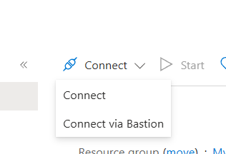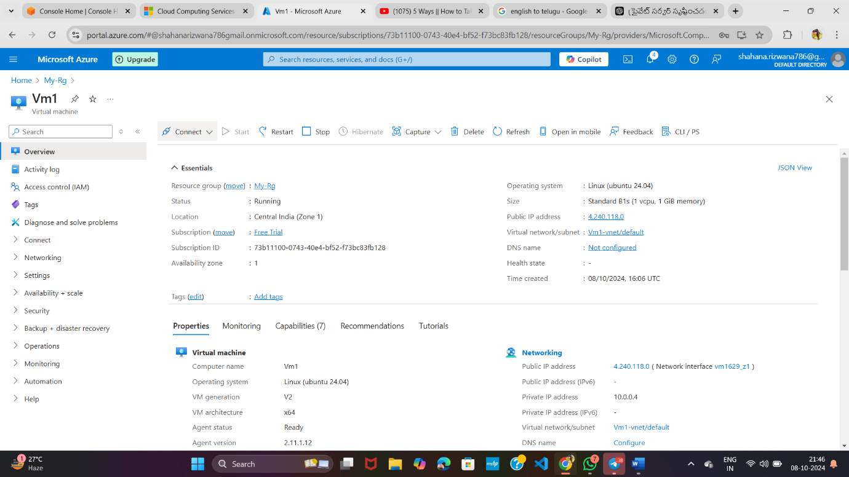

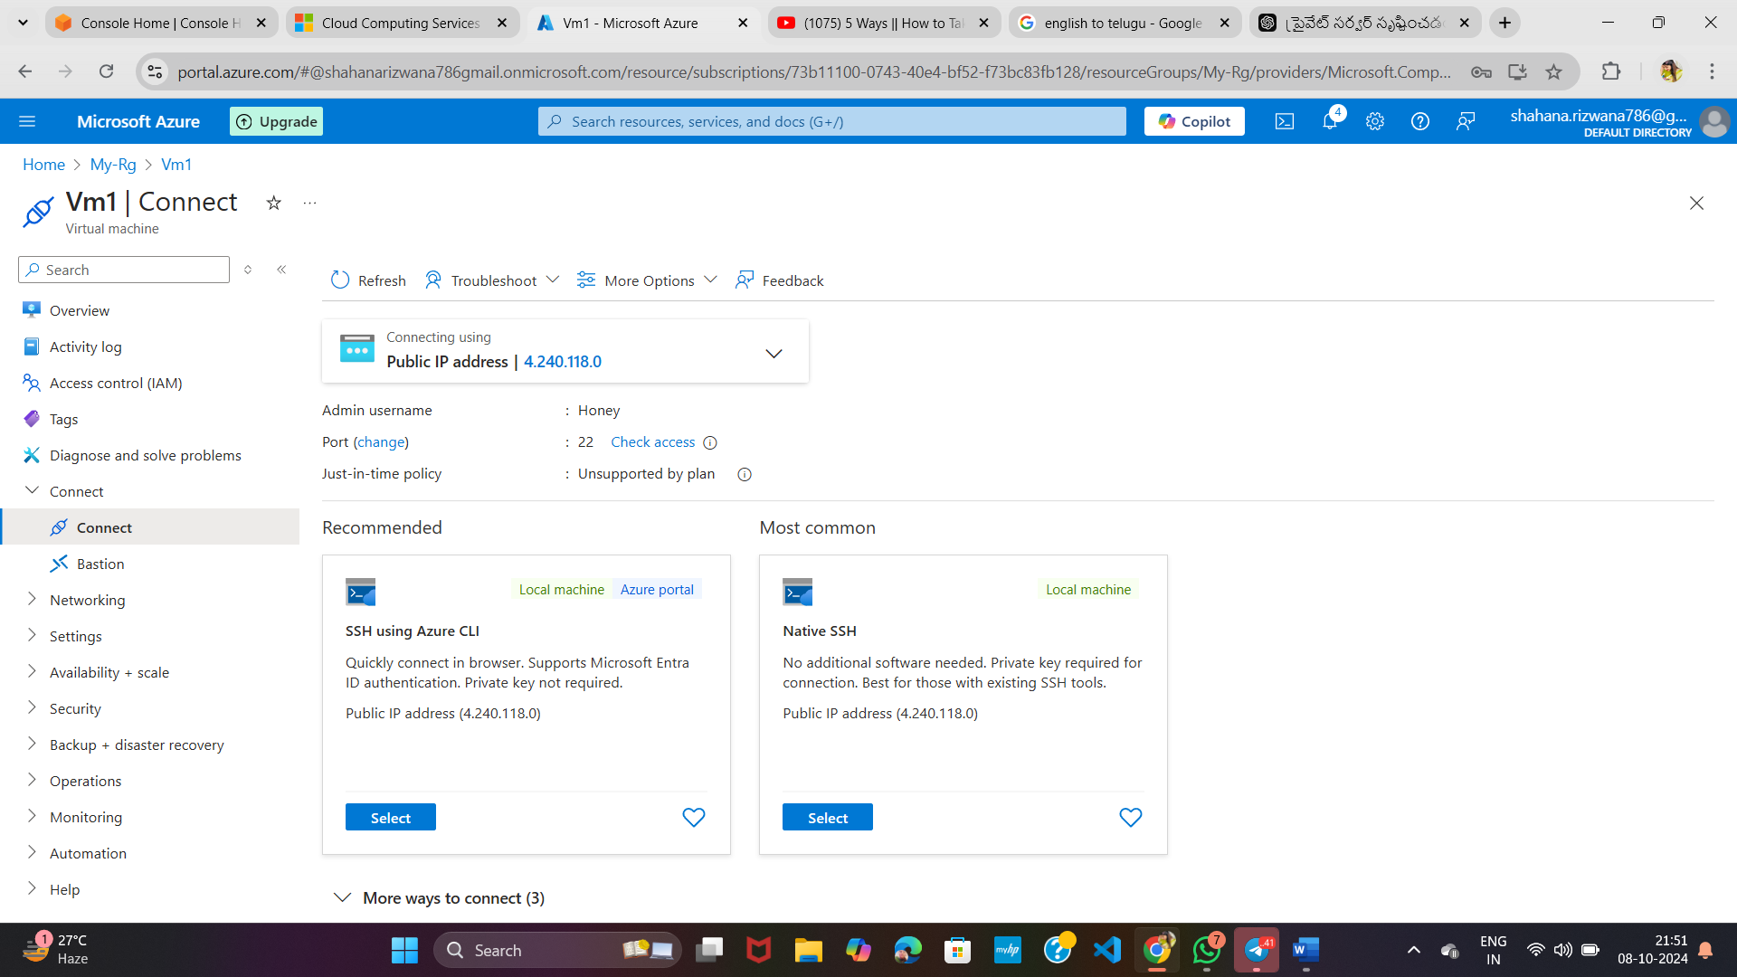

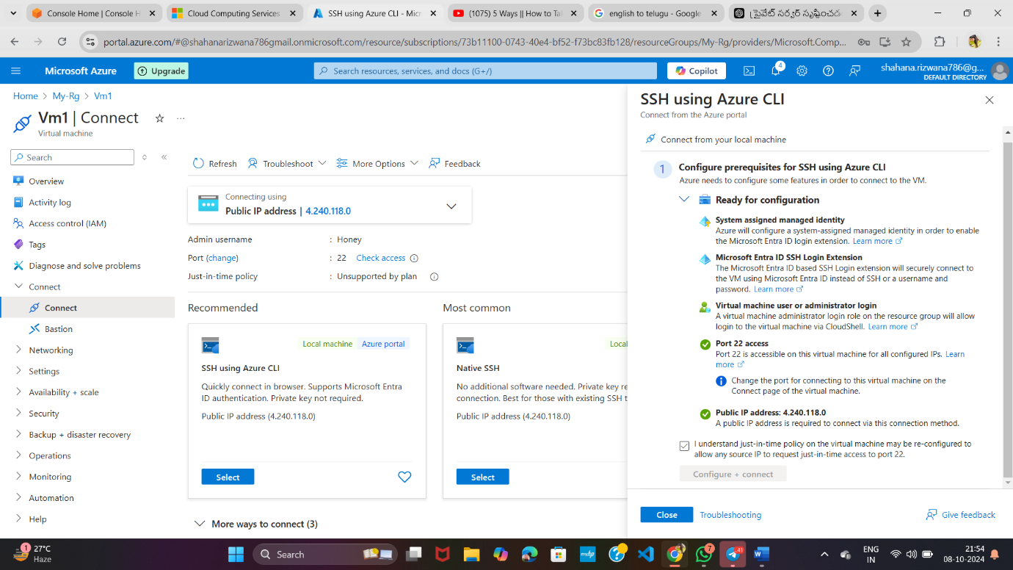

**Tick this box Click on this**

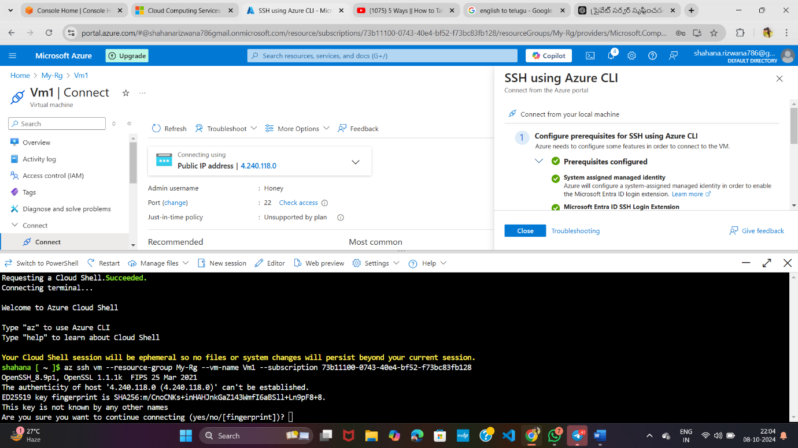

**Give ‘yes’ here**

**\*Then --------sudo apt update**

**\*sudo apt install mysql-server**

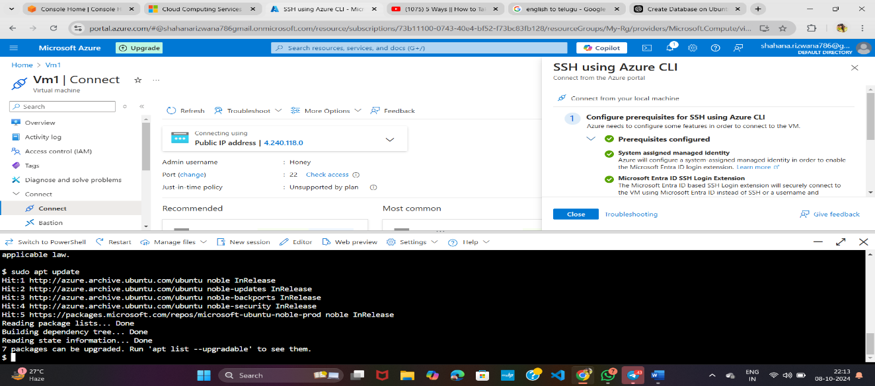

**\*** **sudo mysql_secure_installation**

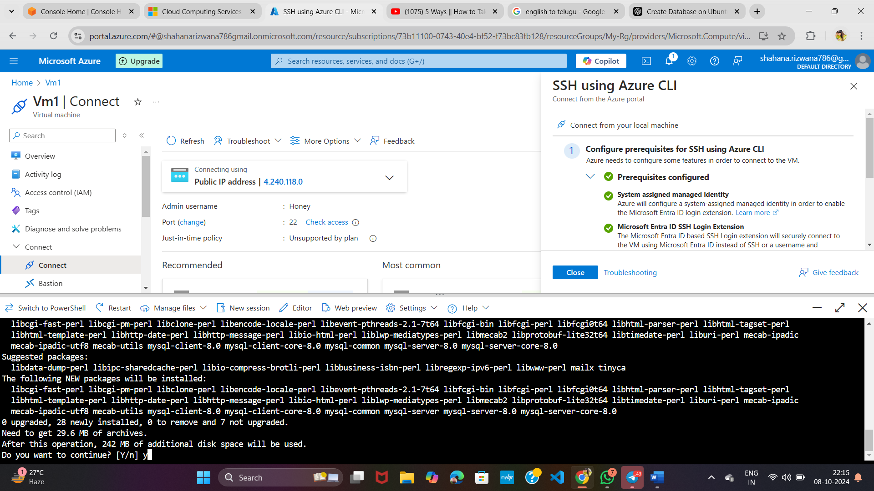

**Give ‘y’ here**

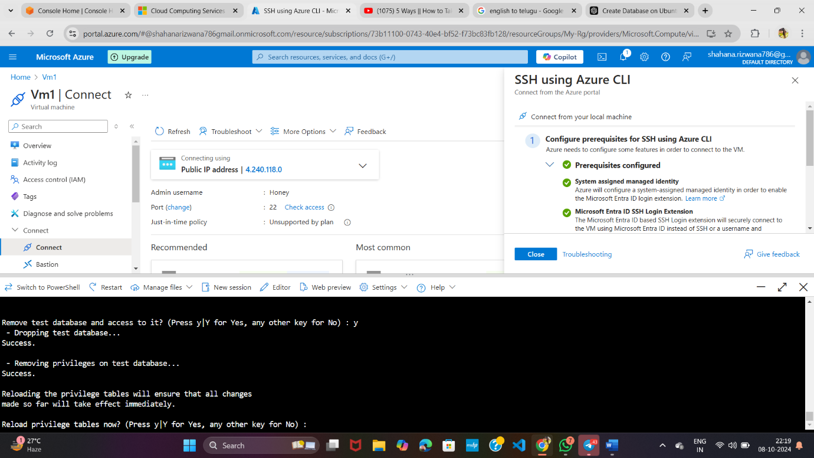

**Give all ‘y’ here**

**\*** **sudo mysql -u root -p**

**\*'jeffrey'@'localhost'--------Default password**

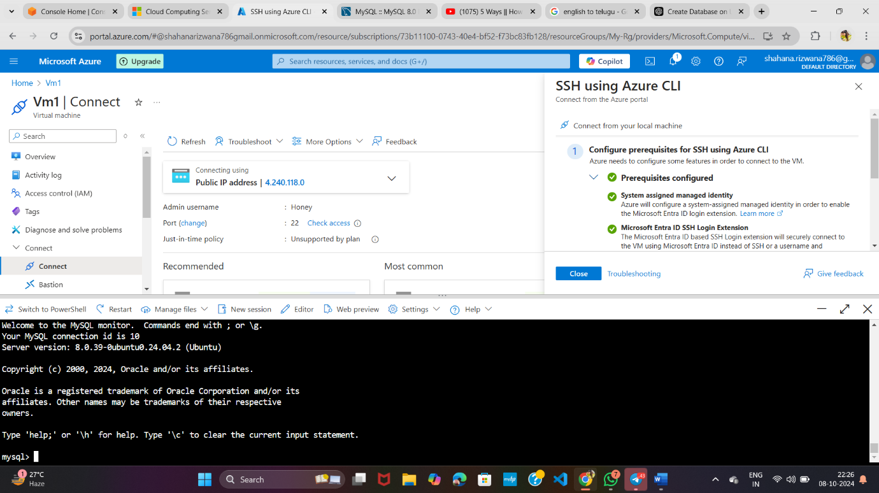

**\*** **CREATE DATABASE your_database_name;**

**\*** **CREATE TABLE your_database_name.your_table_name;**

**\*INSERT INTO your_database_name.your_table_name;**

**\*SELECT * FROM your_database_name.your_table_name;**

